**HC Coding Assessment REST API Description**

**Once the web service is running, it will start up the standard ASP.NET web page, in the default browser. The API formats can be viewed by clicking on the “API” menu item.**

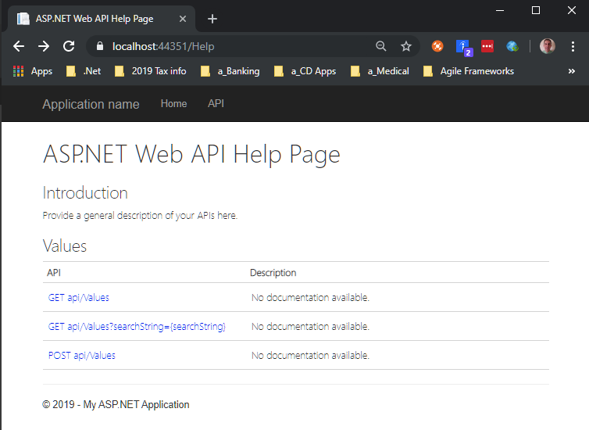

**Get api/values (using Postman)**

**Description:** This RESTful API queries the database for all persons and

returns the data as JSON.

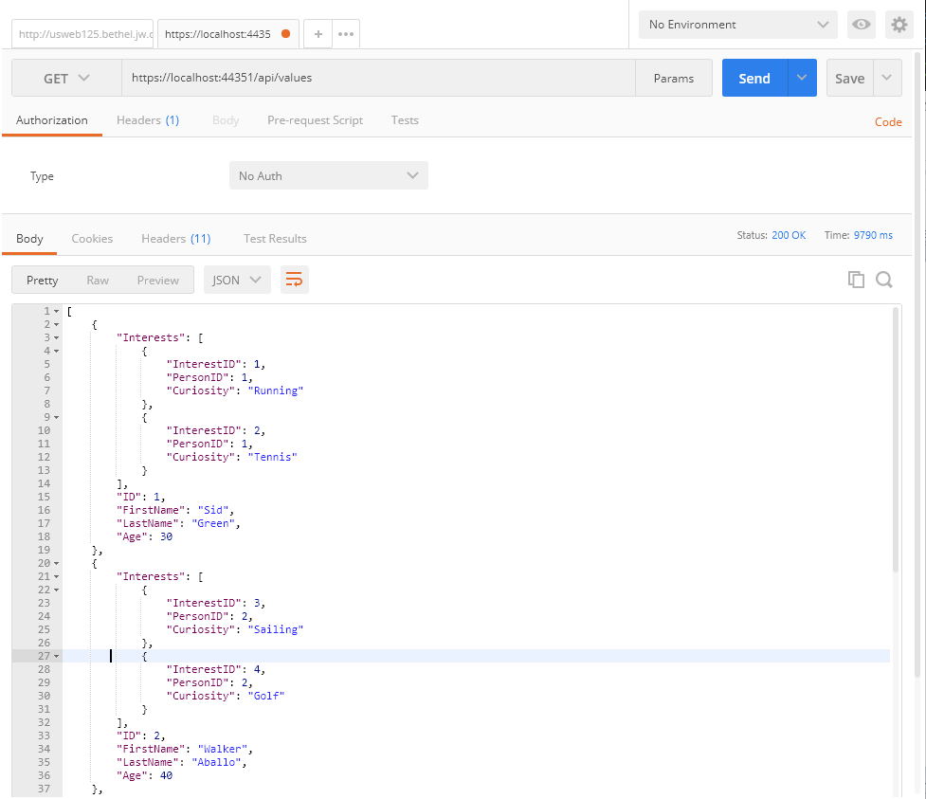

**( The initial returned JSON is based on the current seeded database entries )**

**GET api/Values?searchString={searchString}**

**Description:** This RESTful API queries the database for the selected person, using first or last name and returns the data as JSON.

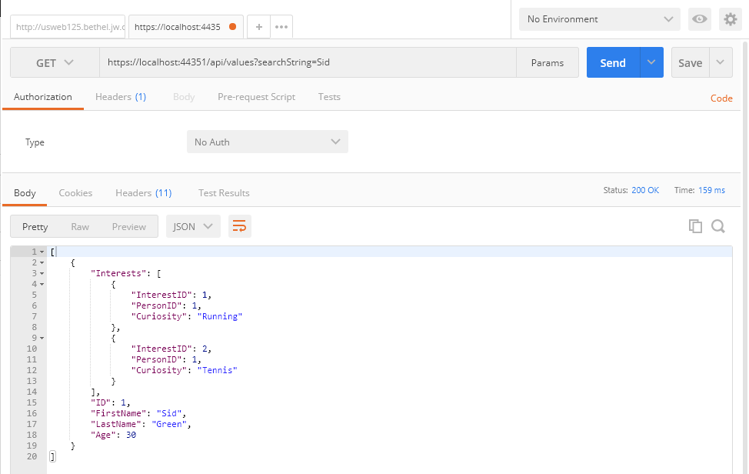

**POST api/Values/Person**

**Description:** This RESTful API accepts a JSON object structure, representing a new person to

add to the Database.

**Settings before click Send:**

1. Set action to POST.
2. Enter in the POST REST API string, as shown below.
3. Set to Body.
4. Set to Raw and JSON (application/json).
5. Enter some JSON containing the Person you want to add.
6. Click Send.

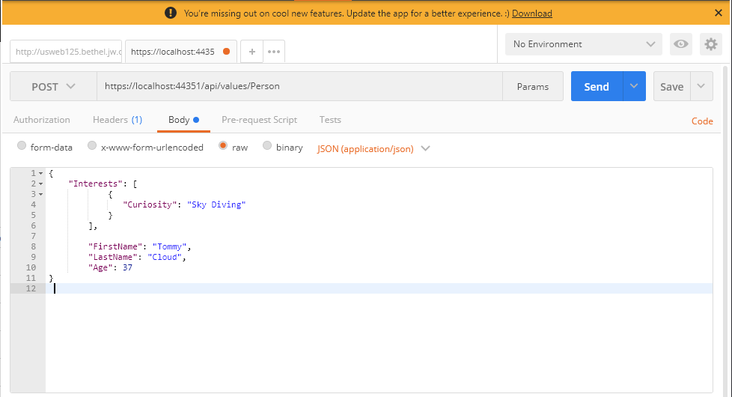

**To Test the previous POST:**

**Run: GET api/Values?searchString={searchString}**

